**Exercise**

**Schedule UIRobot without Orchestrator**

Video: <https://www.youtube.com/watch?v=QuPvuPqYEQ0>

Pre-Condition: Robot should be configured (bots should be created

Stesp:

1. Open Task Schedular
2. Create Folder and create new Task
3. Configure the settings
4. Navigate to Trigger Tab and configure the setting which is required
5. Navigate to Action tab, configured Robot.exe ("C:\Users\Narendra_v\AppData\Local\UiPath\app-18.3.1\UiRobot.exe")

in Script path

and main.xaml (“/file:"D:\UIPath\Narendra\Main.xaml") in Add Arguments field

note:

1. ‘/file and “” should be specified for both argument and script path
2. Add Arguments is optional, in case if we have more than one task then it can be specified
3. **No need to create NuGet package, when task are running in windows Schedular**
4. Add the Condition required
5. Configure the settings
6. Click on Ok button

Not This can be run without opening the Robot Instance and Ui Studio

1. Open Task Schedular

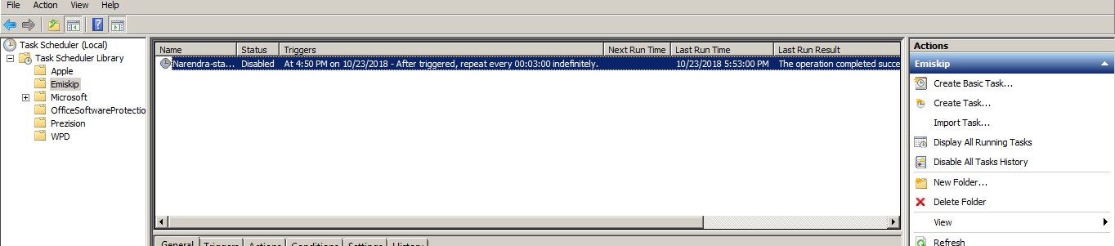

1. Configure the setting in task schedular

